**Disintegration of Tablets**

**CIPAC Collaborative Trial**

**CIPAC Information Sheet No 295**

**German Speaking Working Group for Plant Protection Products (DAPF)**

Dipl.-Ing. (FH) Dieter Walter

Physical-Chemical Properties

Eurofins Agroscience Services EcoChem GmbH

Eutinger Str. 24

75223 Niefern-Öschelbronn, Germany

Dipl.-Ing. (FH) Udo Warncke

Spiess-Urania Chemicals GmbH

Loofter Strasse 9

25593 Christinenthal, Germany

May 2013

**Table of Contents**

1 General information 3

2 List of participants 4

3 Tablets 5

4 Description of the Method 6

5 Results 7

5.1 Ally Tabs 7

5.2 Bayer Garten 3 in 1 9

5.3 Ratio 50 T 11

6 Evaluation of results 13

6.1 Ally Tabs 13

6.2 Bayer Garten 3 in 1 13

6.3 Ratio 50 T 14

7 Conclusion and Recommendation 16

# 1. General information

A method for testing the disintegration behavior of agricultural and public health tablets intended for dissolution or dispersion in water (e.g. ST, WT, …) was developed within the framework of DAPF* and a full scale collaborative trial was carried out using three different types of tablets.

The scope of the method is to determine the completeness of disintegration of tablets independent of the use rate. The method is designed for, but not limited to, the disintegration of effervescent tablets.

**Scope/Aim of the Round Robin**

The objective was to evaluate the repeatability and reproducibility of the proposed method for measuring the completeness of the disintegration of tablets which have to be dissolved or dispersed in water. 12 laboratories from the EU, Switzerland, Argentina, Pakistan and the US participated in the Round Robin and sent back their results. The disintegration properties of three commercially available tablets distributed to the volunteering laboratories were evaluated. One of the tablets was an effervescent tablet.

* Ally Tabs: Two tablets were cut from a blister pack (foil remained sealed) and repacked in a small plastic bag cushioned with chips
* Bayer Garten 3 in 1 was distributed in their original packaging
* Ratio 50 T: Two tablets were repacked in a plastic cup that was cushioned (see fig. 1).

*DAPF = German Working Panel for Plant Protection Products

# 2. List of participants

|  |  |  |
| --- | --- | --- |
| **Country** | **Name** | **Organisation** |
| Argentina | Dr. Héctor E. Di Loreto | Agrofina |
| Pakistan | Atif Khalid | Surfactant Chemicals Company (Pvt) Ltd |
| Germany | Dr. Claudia Vinke | Federal Office of Consumer Protection and Food Safety |
| Germany | Dr. Markus Frauen | StählerTec Deutschland GmbH & Co. KG |
| Slovakia | Dr. Dipl.Ing. Juliana Schlosserova | UKSUP / CCTIA Dept. of Environmental Protection and Organic Protection |
| Germany | Markus Kalt | BASF SE 67056 Ludwigshafen |
| Germany | Dr. Erika Seidel/Welf-Burkhard Wiese | Bayer Crop Science AG-R&D-CPD-FT |
| Germany | Udo Warncke/Dr. Jan Hinrich Ramm | Spiess-Urania Chemicals GmbH |
| Germany | Dr. Thomas Kröhl | BASF SE  Agrarzentrum Limburgerhof |
| Belgium | Ing. Bernard de Ryckel | Walloon Agricultural Research Centre (CRA-W) |
| USA | Alan Viets/Bonnie Bradford | BASF Chemicals and Polymers |
| Switzerland | Bruno Patrian | Agroscope Changins-Wädenswil (ACW) |

The collaborative trial was limited to a maximum of 15 laboratories for logistic reasons. 12 laboratories announced their willingness to participate in the collaborative test. The announcement of one further lab, received after the deadline of 24 August 2012, was refused for the sake of not delaying the shipping of samples and the evaluation of results.

The samples were dispatched from Germany on 14.09.2012:

Laboratories 1 to 9 received the samples in September 2012 and sent their results by the end of October 2012.

The other 3 laboratories received the samples delayed, e.g. at least 2 months after shipment:

Laboratory 10: samples received on 13.12.2012

Laboratory 11: samples received later than 12.10.2012; results sent in on 08.01.2013)

Laboratory 12: samples received on 20.11.2012

Different reasons are responsible for this issue, like import regulation etc.

# 3. Tablets

|  |  |
| --- | --- |
| **Test item 1**  Batch  Kind of formulation  Active ingredient  Stirring time according to the manufacturer | **Ally Tabs**  2079 – 111109 or R204A  Water soluble tablet (ST)  4 % Metsulfuron-methyl  Slight swirling until the tablet is completely dissolved (few minutes) |
| **Test item 2**  Batch  Kind of formulation  Active ingredient  Stirring time according to the manufacturer | **Bayer Garten 3 in 1 Schädlingsfrei Lizetan**  4111535B2176  Water soluble tablet (ST) - effervescent system  25 g/kg Imidacloprid  Slight swirling until the tablet is completely dissolved (few minutes) |
| **Test item 3**  Batch  Kind of formulation  Active ingredient  Stirring time according to the manufacturer | **Ratio 50 T (Harmony Plus Tablet)**  MAR05CE291  Water soluble tablet (ST)  167 g/kg Tribenuron-methyl; 333 g/kg Thifensulfuron-methyl  not specified |

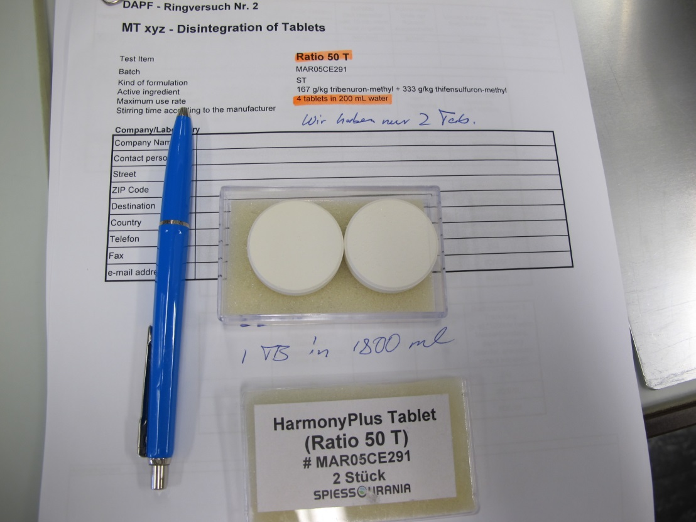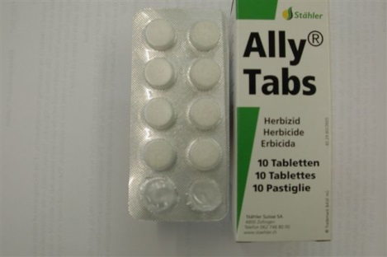Fig. 1 Three different brands of tablets were distributed

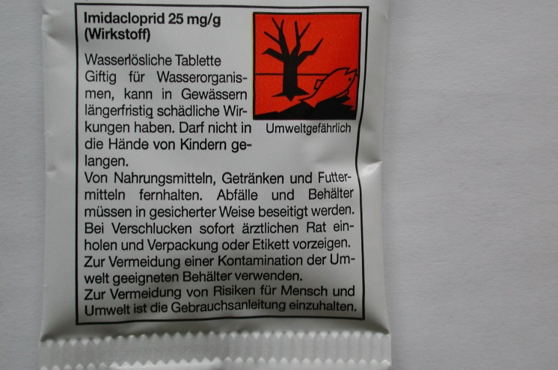

# 4. Description of the Method

* one tablet is added to 1800 ml of CIPAC standard water D which has a temperature of 25 ± 5°C
* stirring with a mechanical stirrer (see Fig. 2) for a specified time following recommendation by the manufacturer of the tablet, generic time 10 minutes
* sieving (2 mm, 200 mm diameter), drying, weighing and calculating the residue similar to the wet sieve test MT 185

Fig. 2 Mechanical stirrer for testing disintegration of tablets

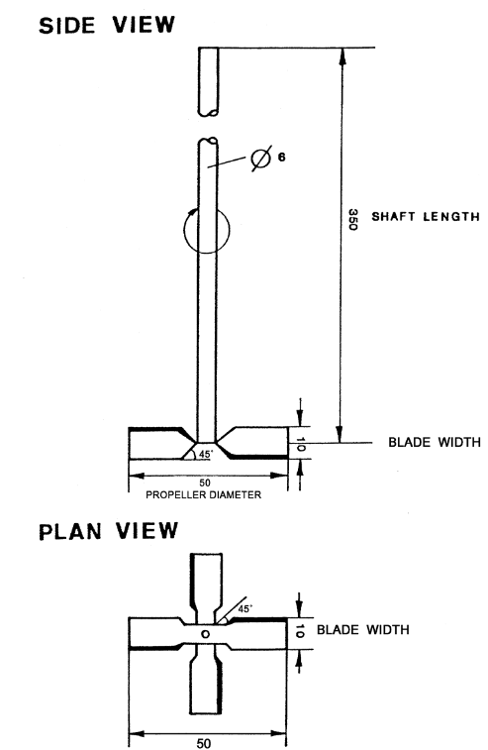

# 5. Results

## 5.1 Ally Tabs

|  |  |  |  |  |  |  |  |  |  |  |  |  |
| --- | --- | --- | --- | --- | --- | --- | --- | --- | --- | --- | --- | --- |
| **Lab** | **Trial No.** | **Weight Standard water D** | **Temp.**  **water D** | **Stirrer pos:**  **(norm:  3 cm )** | **Stirrer speed  (norm:**  **300 ± 10 rpm)** | **Weight of tablet** | **Stirring time [norm: 10 min)** | **Stirrer rinsed?** | **transferred to the 2000 µm Sieve?** | **Beaker and sieve rinsed?** | **Visible residue on Sieve?** | **Residue determined** |
|  |  | **[g]** | **[°C]** | **[cm]** | **[rpm]** | **w [g]** | **[minutes]** | **yes/no** | **yes/no** | **yes/no** | **yes/no** | **[%]** |
| 1 | 1 | 1798.6 | 23.5 | 3 | 296 | 0.5400 | 4.5 | yes | yes | yes | no | no |
| 2 | 1799.5 | 23.5 | 3 | 297 | 0.5398 | 4 | yes | yes | yes | no | no |
| 2 | 1 | 1791.1 | 21.3 | 3 | 300 | 0.53 | 10 | yes | yes | yes | no | no |
| 2 | 1790.2 | 21.3 | 3 | 300 | 0.53 | 10 | yes | yes | yes | no | no |
| 3 | 1 | 1800 | 23 | 3 | 308 | 0.54 | 10 | yes | yes | yes | no | no |
| 2 | 1800 | 23 | 3 | 308 | 0.54 | 10 | yes | yes | yes | no | no |
| 4 | 1 | 1800 | 21.1 | 3 | 299 | 0.5353 | 10 | yes | yes | yes | no | no |
| 2 | 1800 | 23.9 | 3 | 299 | 0.5317 | 10 | yes | yes | yes | no | no |
| 5 | 1 | 1855 | 25.1 | 3 | 300 | 0.5169 | 10 | yes | yes | yes | no | no |
| 2 | 1763 | 25.0 | 3 | 300 | 0.5321 | 10 | yes | yes | yes | no | no |
| 6 | 1 | 1786.5 | 24.8 | 3 | 301 | 0.5391 | 10 | yes | yes | yes | no | no |
| 2 | 1790.7 | 24.9 | 3 | 301 | 0.5269 | 10 | yes | yes | yes | no | no |
| 7 | 1 | 1801 | 20 | 3 | 305 | 0.52 | 3 min 10 sec | yes | yes | yes | no | no |
| 2 | 1798 | 20 | 3 | 305 | 0.54 | 3 min 30 sec | yes | yes | yes | no | no |
| 8 | 1 | 1797.24 | 23.5 | 3 | 300 | 0.522 | 10 | yes | yes | yes | no | no |
| 2 | 1797.85 | 23.5 | 3 | 300 | 0.527 | 10 | yes | yes | yes | no | no |
| 9 | 1 | 1815.56 | 22 | 3 | 300 | 0.5285 | 10 | yes | yes | yes | no | no |
| 2 | 1820.91 | 22 | 3 | 300 | 0.5316 | 10 | yes | yes | yes | no | no |
| 10 | 1 | 1800 | 25 | 3 | 300 | 0.5304 | 10 | yes | yes | yes | no | no |
| 2 | 1800 | 25 | 3 | 300 | 0.5393 | 10 | yes | yes | yes | no | no |
| 11 | 1 | 1801 | 24 | 3 | #2 setting | 0.52 | 5 | yes | yes | yes | no | no |
| 2 | 1796 | 24 | 3 | #2 setting | 0.52 | 5 | yes | yes | yes | no | no |
| 12 | 1 | 1802 | 25.1 | 3 | 300 | 0.5343 | 10 | yes | yes | yes | no | no |
| 2 | 1803 | 25.1 | 3 | 300 | 0.5269 | 10 | yes | yes | yes | no | no |

|  |  |
| --- | --- |
| **Laboratory** | **Comments: Ally Tabs** |
| 1 | Stirring time until the tablet is completely dissolved. |
| 2 | no |
| 3 | no |
| 4 | no |
| 5 | After 10 min both tablets show some fine particles in CIPAC water D. Batch number was R204A. |
| 6 | no |
| 7 | Tablet diameter about 1.2 cm. A suspension was formed after dilution - the suspension passed the test sieve without any problems. |
| 8 | Tablet 1 was dissolved after 3 min 38 sec, tablet 2 was dissolved after 3 min 43 sec. |
| 9 | As no use information was provided with tablets, all tablets were stirred for 10 minutes. Tablets had disintegrated after  3.5 min (tablet 1) and 4min (tablet 2), but undissolved small, white particles remained in suspension. Therefore, stirring was continued for a total of 10min. The particles remained undissolved after a total of 10 min. After transfer of the content of the beaker to the sieve and rinsing with water, no residues remained on the sieve. |
| 10 | Tablets 1 and 2 dissolve completely at 4min40sec and 5min, respectively. |
| 11 | no |
| 12 | no |

# 5.2 Bayer Garten 3 in 1

|  |  |  |  |  |  |  |  |  |  |  |  |  |
| --- | --- | --- | --- | --- | --- | --- | --- | --- | --- | --- | --- | --- |
| **Lab** | **Trial No.** | **Weight Standard water D** | **Temp.**  **water D** | **Stirrer pos:**  **(norm:  3 cm )** | **Stirrer speed  (norm: 300 ±**  **10 rpm,** | **Weight of tablet** | **Stirring time [norm:  10 min)** | **Stirrer rinsed?** | **transferred to the 2000 µm Sieve?** | **Beaker and sieve rinsed?** | **Vis. Res. on Sieve?** | **Residue determined** |
|  |  | **[g]** | **[°C]** | **[cm]** | **[rpm]** | **w [g]** | **[minutes]** | **yes/no** | **yes/no** | **yes/no** | **yes/no** | **[%]** |
| 1 | 1 | 1800.7 | 23 | 3 | 296 | 2.0037 | 2 | yes | yes | yes | no | no |
| 2 | 1800.4 | 23 | 3 | 298 | 1.9952 | 2 | yes | yes | yes | no | no |
| 2 | 1 | 1788.7 | 21.3 | 3 | 300 | 2.08 | 10 | yes | yes | yes | no | no |
| 2 | 1790.7 | 21.3 | 3 | 300 | 2.00 | 10 | yes | yes | yes | no | no |
| 3 | 1 | 1800 | 23 | 3 | 309 | 2.01 | 10 | yes | yes | yes | no | no |
| 2 | 1800 | 23 | 3 | 309 | 2.09 | 10 | yes | yes | yes | no | no |
| 4 | 1 | 1800 | 20.0 | 3 | 294 | 2.0077 | 10 | yes | yes | yes | no | no |
| 2 | 1800 | 20.0 | 3 | 299 | 2.0108 | 10 | yes | yes | yes | no | no |
| 5 | 1 | 1760 | 25.9 | 3 | 300 | 2.0874 | 10 | yes | yes | yes | no | no |
| 2 | 1742 | 26.1 | 3 | 300 | 2.0987 | 10 | yes | yes | yes | no | no |
| 6 | 1 | 1791.8 | 24.8 | 3 | 300 | 2.0079 | 10 | yes | yes | yes | no | no |
| 2 | 1786.1 | 24.9 | 3 | 300 | 1.9964 | 10 | yes | yes | yes | no | no |
| 7 | 1 | 1802.8 | 20 | 3 | 302 | 2.09 | 10 | yes | yes | yes | no | no |
| 2 | 1801.6 | 20 | 3 | 307 | 2.09 | 4 | yes | yes | yes | no | no |
| 8 | 1 | 1798.55 | 23.2 | 3 | 300 | 2.019 | 10 | yes | yes | yes | no | no |
| 2 | 1798.40 | 23.2 | 3 | 300 | 2.112 | 10 | yes | yes | yes | no | no |
| 9 | 1 | 1817.86 | 22 | 3 | 300 | 2.0027 | 10 | yes | yes | yes | no | no |
| 2 | 1816.84 | 22 | 3 | 300 | 2.0353 | 10 | yes | yes | yes | no | no |
| 10 | 1 | 1800 | 25 | 3 | 300 | 1.6756 | 10 | yes | yes | yes | yes | **10.9 %** 1st (1 h at 60 °C), **10.3 %** 2nd (0.5 h at 60 °C), **10.3 %** 3rd drying (0.5 h at 60 °C). |
| 2 | 1800 | 25 | 3 | 300 | 2.0208 | 10 | yes | yes | yes | yes | **0.6 %** 1st (1 h at 60 °C), **0.6 %** 2nd (0.5 h at 60 °C), **0.6 %** after 3rd drying (0.5 h at 60 °C) |
| 11 | 1 | - | 23 | 3 | #3 setting | 1.63 | 10 | yes | yes | yes | no | no |
| 2 | - | 24 | 3 | #2 setting | 2.02 | 5 | yes | yes | yes | no | no |
| 12 | 1 | 1803 | 25.1 | 3 | 300 | 1.9223 | 10 | yes | yes | yes | no | no |
| 2 | 1801 | 25.1 | 3 | 300 | 1.8102 | 10 | yes | yes | yes | no | no |

|  |  |
| --- | --- |
| **Laboratory** | **Comments: Bayer Garten 3 in 1** |
| 1 | After 1.5 min stirring time the tablet swims to the top of the beaker and disintegrates completely. Stirring time until the tablet is completely dissolved. |
| 2 | Around the stirrer foam is generated. |
| 3 | no |
| 4 | no |
| 5 | Both tablets shows a white, crystalline solids on the top, nearly the stirrer, no agglomeration. After 10 min there are less fine particles in CIPAC water D. Batch number was 4111535B2176. |
| 6 | no |
| 7 | Tablet diameter about 2.4 cm. The tablet was dissolved after about 4 minutes completely. The remains of the tablets were floating to the surface near the stirrer and remained there in a small portion of foam formed the stirring. Although some small particles were visible in the solution, no problems were observed by passing the test sieve. For the first Trial the stirring time was set to 10 minutes in order to try a complete solvation of these small particles. |
| 8 | Tablet 1 was dissolved after 4 min, tablet 2 was dissolved after 2 min 8 sec. |
| 9 | As no use information was provided with tablets, all tablets were stirred for 10 minutes. Tablets had disintegrated after 3 min (tablet 1) and 3 min (tablet 2). Very few undissolved small, white particles remained in a slightly turbid solution. Therefore, stirring was continued for a total of 10 min. The particles remained undissolved after a total of 10min. After transfer of the content of the beaker to the sieve and rinsing with water, no residues remained on the sieve. |
| 10 | Trial No. 1: the surface of the tablet, as taken from the package, is not uniform and seems granular. During the assay the tablet floats, no evolution of gas is observed. Trial No. 2: the surface of the tablets appears smooth, contrary to what was observed in the first tablet. During the assay the sample stays at the bottom of the beaker. Gas is evolved as the tablet progressively dissolves. |
| 11 | Unit #1 tablet had about 30% erosion when removed from package. Unit #2 tablet had about 5 % erosion when removed from package |
| 12 | no |

# 5.3 Ratio 50 T

|  |  |  |  |  |  |  |  |  |  |  |  |  |  |
| --- | --- | --- | --- | --- | --- | --- | --- | --- | --- | --- | --- | --- | --- |
| **Lab** | **Trial No.** | **Weight Standard water D** | **Temp.**  **water D** | | **Stirrer pos:**  **(norm:  3 cm )** | **Stirrer speed  (norm: 300 ±**  **10 rpm** | **Weight of tablet** | **Stirring time [norm  10 min)** | **Stirrer rinsed?** | **transferred to the 2000 µm Sieve?** | **Beaker and sieve rinsed?** | **Vis. Res. on Sieve?** | **Residue determined** |
|  |  | **[g]** | | **[°C]** | **[cm]** | **[rpm]** | **w [g]** | **[minutes]** | **yes/no** | **yes/no** | **yes/no** | **yes/no** | **[%]** |
| 1 | 1 | 1799.9 | | 23 | 4 | 296 | 7.2045 | 10 | yes | yes | yes | no | no |
| 2 | 1800.0 | | 23 | 4 | 296 | 7.0632 | 10 | yes | yes | yes | no | no |
| 2 | 1 | 1789.4 | | 21.3 | 3 | 300 | 7.14 | 10 | yes | yes | yes | no | no |
| 2 | 1792.4 | | 21.3 | 3 | 300 | 7.12 | 10 | yes | yes | yes | no | no |
| 3 | 1 | 1800 | | 23 | 4 | 306 | 7.04 | 10 | yes | yes | yes | no | no |
| 2 | 1800 | | 23 | 4 | 306 | 7.09 | 10 | yes | yes | yes | no | no |
| 4 | 1 | 1800 | | 20.8 | 3 | 304 | 7.0259 | 10 | yes | yes | yes | no | no |
| 2 | 1800 | | 20.8 | 3 | 299 | 7.1079 | 10 | yes | yes | yes | no | no |
| 5 | 1 | 1740 | | 26.0 | 5 | 300-310 | 7.1720 | 10 | yes | yes | yes | no | no |
| 2 | 1750 | | 26.0 | 5 | 300-310 | 7.0925 | 10 | yes | yes | yes | no | no |
| 6 | 1 | 1786.5 | | 24.8 | 3 | 301 | 6.9938 | 10 | yes | yes | yes | no | no |
| 2 | 1791.6 | | 24.9 | 3 | 301 | 7.0155 | 10 | yes | yes | yes | no | no |
| 7 | 1 | 1799.8 | | 20 | 3 | 300 | 7.18 | 10 | yes | yes | yes | no | no |
| 2 | 1800.8 | | 20 | 3.5 | 297 | 7.13 | 10 | yes | yes | yes | no | no |
| 8 | 1 | 1798.86 | | 24.0 | 3 | 300 | 7.166 | 10 | yes | yes | yes | no | no |
| 2 | 1797.71 | | 24.0 | 3 | 300 | 7.165 | 10 | yes | yes | yes | no | no |
| 9 | 1 | 1817.46 | | 22 | 3 | 300 | 7.0905 | 10 | yes | yes | yes | no | no |
| 2 | 1816.45 | | 22 | 3 | 300 | 7.1822 | 10 | yes | yes | yes | no | no |
| 10 | 1 | 1800 | | 25 | 3 | 300 | 6.9981 | 10 | yes | yes | yes | yes | **18.9 %** 1st (1 h at 60 °C), **17.2 %** 2nd (1 h at 60 °C), **17.1 %** 3rd drying (1 h at 60 °C). |
| 2 | 1800 | | 25 | 3 | 300 | 6.9759 | 10 | yes | yes | yes | yes | **14.7 %** 1st (1 h at 60 °C), **13.0 %** 2nd (1 h at 60 °C), **13.0 %** 3rd drying (1 h at 60 °C). |
| 11 | 1 | 1803.74 | | 23 | 3 | #2 setting | 7.07 | 10 | yes | yes | yes | yes | Error (see comments): at least 1.8 % after 1st drying (1h at 65°C). |
| 2 | 1799.89 | | 23 | 3 | #2 setting | 7.07 | 10 | yes | yes | yes | yes | **4,8 %** 1st (1h at 65°C) and **4.5 %** after 2nd drying (1h at 65°C). |
| 12 | 1 | 1800 | | 25.1 | 3 | 300 | 6.8673 | 10 | yes | yes | yes | yes | **4.8 %** after 1st (0.5h at 65°C), **4.8 %** after 2nd drying (0.5h at 65°C) and **4,8 %** after 3rd drying (0.5h at 65°C) |
| 2 | 1800 | | 25.1 | 3 | 300 | 6.9642 | 10 | yes | yes | yes | no | no |

|  |  |
| --- | --- |
| **Laboratory** | **Comments Ratio 50 T** |
| 1 | After approx. 1 min stirring time, the dispersion is cloudy, so that the tablet and stirrer are no longer visible. |
| 2 | Tablet is thrown against the stirrer and small pieces chipped of. The solution is very cloudy. |
| 3 | no |
| 4 | no |
| 5 | Starts with 300rpm after 5 min stirrer has been speeded up to 310 rpm for checkup sedimentation and solubility. After 10 minutes both tablets are milky and turbid in CIPAC water D, also a little bit foam on the top. |
| 6 | no |
| 7 | Tablet diameter about 3.2 cm. A cloudy suspension was formed after the addition of the tablet. In the first trial the tablet get in contact with the stirring blade. For the second trial the height of the stirring blade was corrected and no interference with the tablet occurred. |
| 8 | no |
| 9 | As no use information was provided with tablets, all tablets were stirred for 10 minutes. Tablets had disintegrated after 7.5 min (tablet 1) and 5 min (tablet 2). It was difficult to see whether undissolved particles remained in the milky-white solution. When checking the beaker from the bottom, a bit of sediment was visible. Therefore, stirring was continued for a total of 10min. The particles remained undissolved after a total of 10min. After transfer of the content of the beaker to the sieve and rinsing with water, no residues remained on the sieve. |
| 10 | no |
| 11 | **Error** with Unit #1: There were problems with transferring content from the sieve to the glass dish. The transfer did not take place **immediately** and thus some residue stuck on the sieve and was difficult to transfer. **The entire residue was not moved to the glass dish**. |
| 12 | no |

# 6. Evaluation of results

## 6.1 Ally Tabs

* results were received from all laboratories
* the weight of all tablets was similar
* the stirrer position chosen by all labs was 3 cm above the bottom of the baker
* the stirrer speed was set by 11 labs to around 300 rpm, 1 lab “#2 setting”.
* The temperature of the CIPAC D standard water was between 20.0 to 25.1 °C.
* three labs stopped the stirring time after the complete disintegration of the tablet (3 min 10 seconds – 5 minutes). The further labs used a stirring time of 10 minutes.
* All 12 labs reported no visible residue on the 2 mm sieve after the transfer of the content to the sieve

**Summary:** Based on the results of Ally Tabs there was no outliner detected. The different stirring times and the different temperature of the CIPAC standard water apparently had no influence of the results.

## 6.2 Bayer Garten 3 in 1

* results were received from all laboratories
* the weight of all tablets was similar with three exceptions. Lab 10 first tablet weighed 1.68 g, Lab 11 first tablet weighed 1.63 g and Lab 12 second tablet 1.81 g instead of the average weight of 1.99 g.
* the stirrer position chosen by all labs was 3 cm above the bottom of the baker
* the stirrer speed was set by 11 labs to around 300 rpm, 1 lab “#2 setting and #3 setting”.
* the temperature of the CIPAC D standard water was between 20 to 26.1 °C.
* three labs stopped the stirring after complete disintegration of the tablet (2 min – 5 min). The further labs used a stirring time of 10 minutes.
* 11 labs reported “no visible residue on the 2 mm sieve” after the transfer of the content to the sieve. Lab 10 reported for the first sample a residue of 10.3 % and for the second a residue of 0.6 %, both after 3rd drying.

After receiving the results we asked lab 10 for further information about the aspect of the tablets. We received the following answer:

*“As specified in the method description, we used a 2000 um sieve. During the assay, both with the Bayer Garden and Ratio 50 T, we observed that the tablets didn’t disintegrate completely, and that after the specified time both remained as a whole piece (didn’t shatter or broke in smaller pieces). In the case of the Bayer Garden Tablet, we observed a considerable difference in the behavior of the tablet between replicates, one of the tablets (the one with a residue of 10.27 %) remained in the surface while stirring and didn’t evolve any gas, while the other (0.60 % residue), sank to the bottom of the beaker and evolved a considerable amount of gas”.*

We asked lab 10 for further information about the condition of the package: We received the following answer:

*”We didn’t find any noticeable difference in the package of the tables, but as we submitted as a comment with the data, there were differences in the appearance of the tablets (details can be found in the excel file we submitted). We used a 2000 µm sieve, mesh number 10.”*

**Summary:** The results of the tablets “Bayer Garten 3 in 1” show 1 outliner. Based on the comment from Lab 10 “*Trial No. 1: the surface of the tablet, as taken from the package, is not uniform and seems granular. During the assay the tablet floats, no evolution of gas is observed*” we concluded that the package of the tablet or the tablet itself had been damaged. A second indicator for the explanation is the lower weight of the tablet. However the laboratory had not observed any difference in the package of the tablet.

The residue of 0.6% for the second tablet (of lab 10) is acceptable because this fits to a residue of about 1 - 3 particles on the sieve.

Without the outlier the results are good and demonstrate the robustness of the method.



Fig 3: Particle from Bayer Garten 2 in 1 (picture from Eurofins Agroscience Services EcoChem GmbH, coorganizer of the trial)

## 6.3 Ratio 50 T

* results were received from all laboratories
* the weight of all tablets was quite similar between 6.9 – 7.2 g.
* 8 labs used a stirrer position 3 cm above the bottom of the beaker,. one lab 3 and 3.5 cm, two other labs 4 cm and, finally, 1 lab a distance of 5 cm.
* the stirrer speed was set by 11 labs to around 300 rpm, 1 lab used “#2 setting”.
* The temperature of the CIPAC D standard water was between 20 to 26.0 °C.
* The stirring time was always 10 minutes.
* 9 labs reported no visible residue on the 2 mm sieve after the transfer of the content to the sieve.   
  Lab 10 reported residues of 17.1 % after 3rd drying and 13.0 % after 3rd drying  
  Lab 11 reported residues of at least 1.8 % (error, see comments) and 4.5 % after 2nd drying  
  Lab 12 reported a residue of 4.8% after 3rd drying and no residue

Based on the comment of Lab 11 *“Error with Unit #1: There were problems with transferring content from the sieve to the glass dish. The transfer did not take place immediately and thus some residue stuck on the sieve and was difficult to transfer. The entire residue was not moved to the glass dish”* we concluded that this result is not valid and we omitted it in the evaluation of the results.

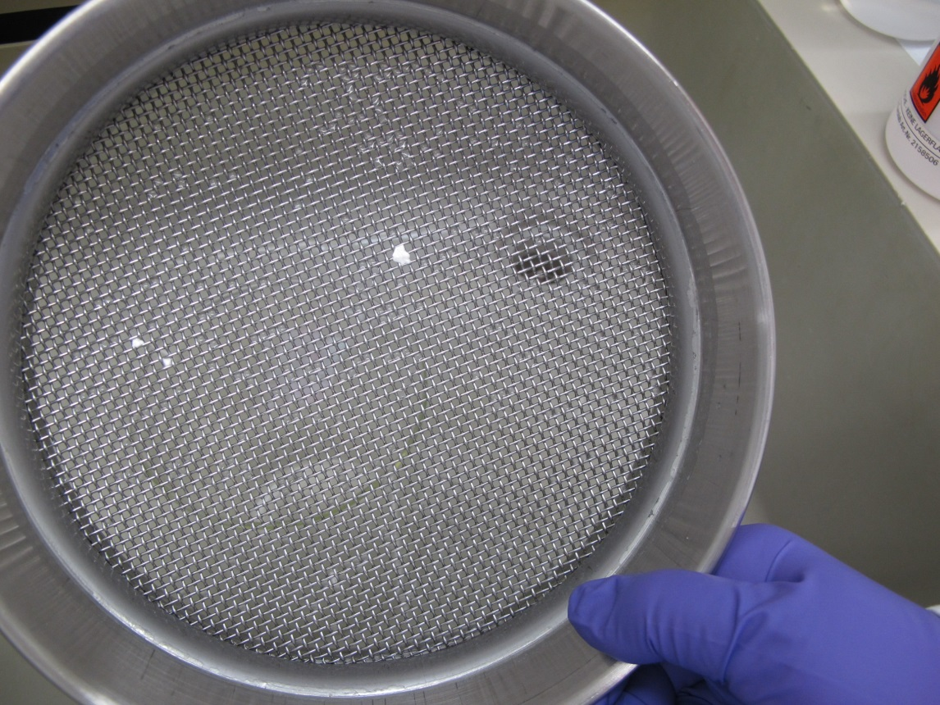

Fig 4: Particles on the 2 mm sieve (picture from Syngenta, participant of the trial)

**Summary:** The results for the tablets Ratio 50 T show that there are 3 laboratories with quantifiable residues. However these 3 labs received the samples at least 2 months later than all other participants. Furthermore, the Ratio 50 T tablets were removed from the original packaging and repacked for the distribution to the participating laboratories. Therefore we conclude that the repackaging and the long transport (high temperature, humidity) have a significant influence of the results and are responsible for the residues observed.

**7 Conclusion and Recommendation**

The round robin test demonstrates the applicability and robustness of the proposed method to determine the completeness of the disintegration of tablets.

* Ally tabs: We detected no outliner.
* Bayer Garten 3 in 1: One outliner detected and deleted. The further 23 results demonstrate the applicability and robustness of the method.
* Ratio 50 T: One result is not valid and was deleted. 19 results detected no residues. 4 tablets give residues. As we have explained in chapter 6.3 we believe that the detected residues are not a problem of the method but are caused by the uncontrolled storage package during the long transportation. Note that the tablets were removed from the original packaging by the organizer of the trial to distribute the tablets to the participants. On the other hand we believe that these different results demonstrate the purpose and usability of this new method.

We recommend that the proposed method be adopted as provisional CIPAC Method.